Semerdale Herd dispersed with top of 2500 guineas

Congratulations to the Bell family on the sale of their goof Semerdale herd at Gisburn Auction Mart. A great crows of local buyers as well as from as far a field as Wales, Scotland and Northumberland.
Leading the slae was a super fresh 3rd calver giving almost 50kg, Semerdale Aventador Lotje VG87, she was purchased by Messrs Lancaster, Beadale for 2500 gns.
In calf heifers were a great trade with the top of 2200gns travelling to R Morgan, Aberystwyth. Topping the young stock was a stylish red yearling from the herd good Sherry family. She was sold to the Atkinson family for 1150gns.

Semerdale Aventador Lotje VG87 2500gns M Lancaster, Beadale
Semerdale Mayday Pansy 2380gns D Coulthurst, Preston
Semerdale Destry Christmas VG88 2350gns Metcalfe Farms
Semerdale Wyman Vaakje VG86 2300gns I Richie, Fife
Semerdale Jotan Lena Red EX92 2200gns W Oldfield, Gisburn
Semerdale Demon Vaakje 2200gns R Morgan, Aberystwyth
Averages:
Cows in milk(2nd Lactation and above avg. £1,792
Heifers in milk avg. £ 1,852
In calf heifers avg. £1,902
13 Maiden Heifers avg. £ 995

LOT 32 : Semerdale Aventador Lotje VG87,
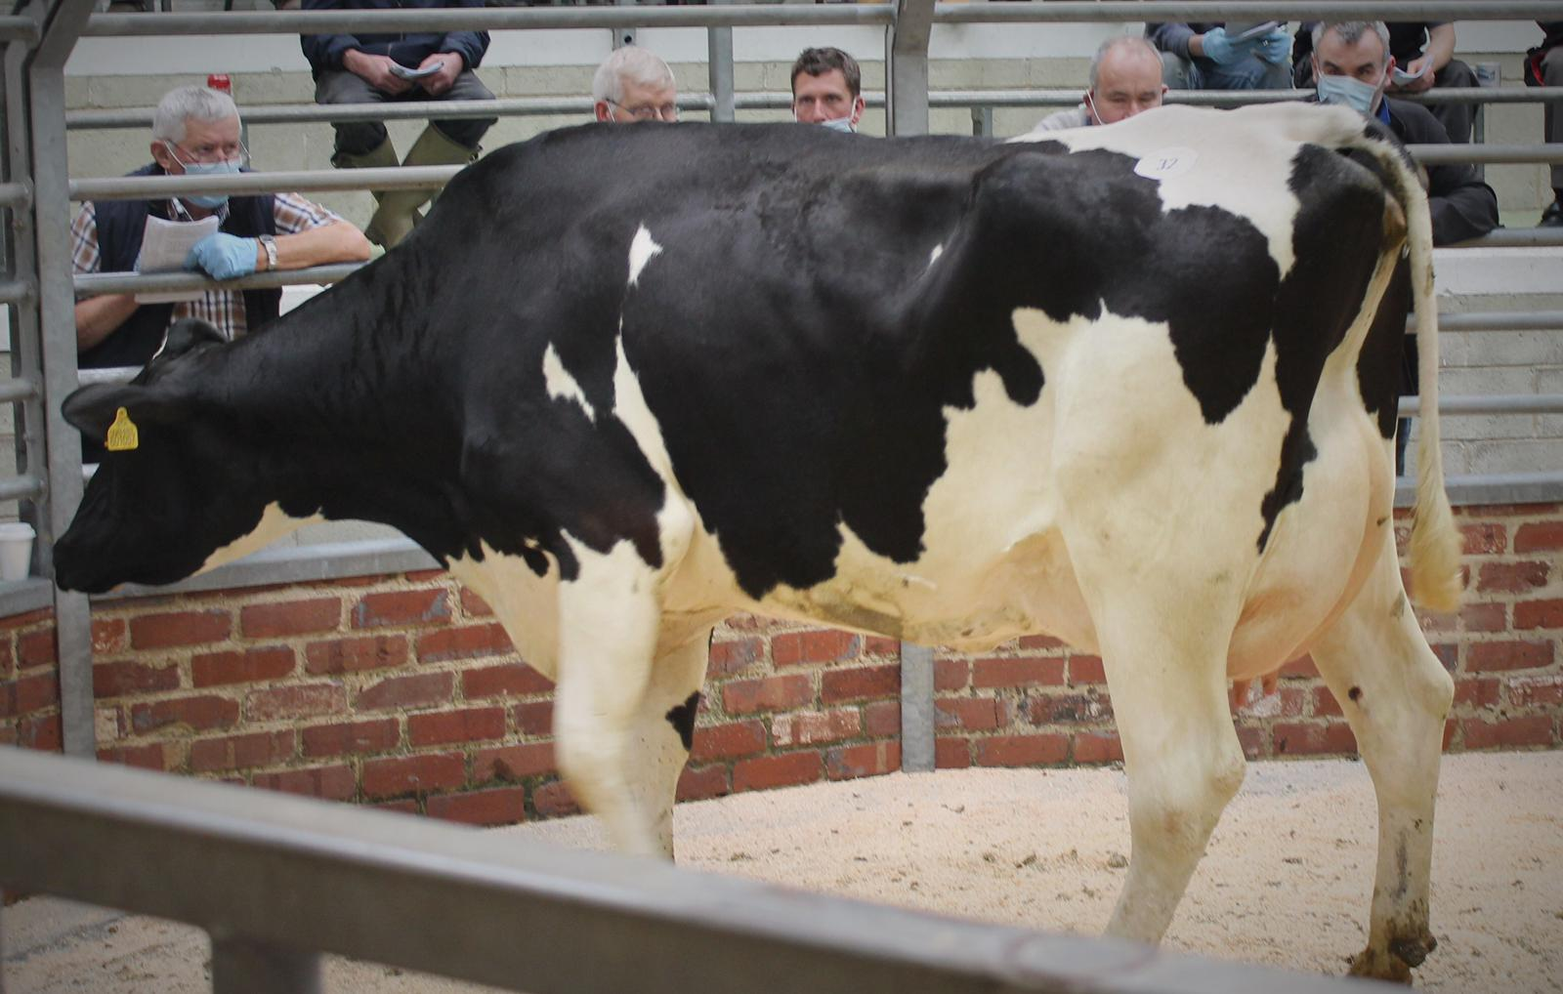

LOT 56 : Semerdale Mayday Pansy 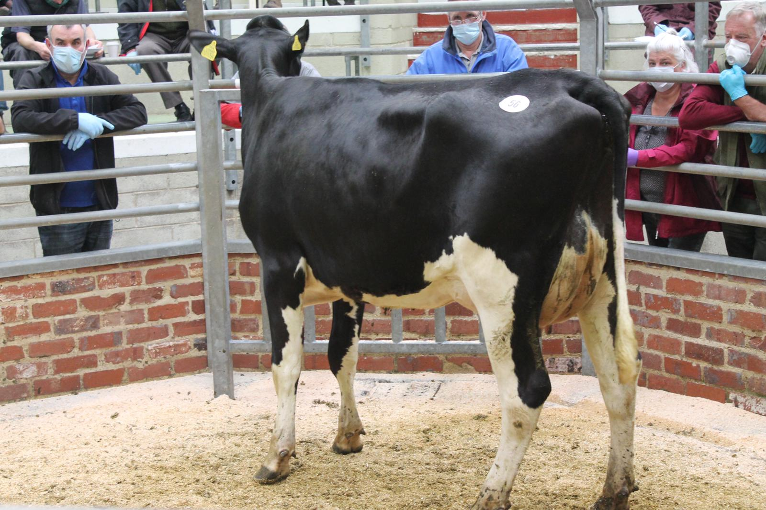

Auctioneers: NORTON & BROOKSBANK

